**AI Final Exam**

**Exam Date: 25-Feb-2024 9:00am**

**Submitted Date: 25-Feb-2024 12:00pm**

Theory (10pts)

1. Explain in detail what is Training Set, Validation Set, and Testing Set?

* The training set is the portion of the dataset used to train the machine learning model. It consists of a large number of labeled examples, where each example comprises input data (features) and the corresponding correct output (labels or target variable).
* The validation set is used to evaluate the performance of the model during training and to fine-tune its hyperparameters
* The testing set is a completely independent dataset that the model has never seen during training or validation. It is used to provide an unbiased evaluation of the model's performance after training and hyperparameter tuning

1. Regarding the figure below, what is Underfitting, Good Models, Overfitting?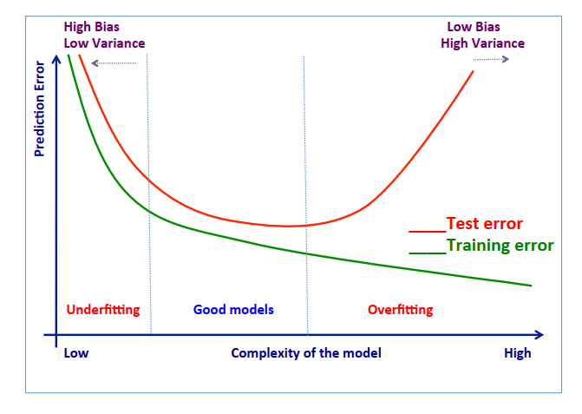
2. In case of Overfitting existing, how to fix it and please explain in details?
3. Below Confusion Matrix, please calculate the value of these term and explain:

|  |  |  |  |
| --- | --- | --- | --- |
|  |  | Actual | |
|  |  | Orange | Banana |
| Prediction | Orange | 45 | 5 |
| Banana | 20 | 60 |

* 1. Accuracy
  2. Precision
  3. Recall
  4. specificity
  5. FI measure